USE OF SURVEY FEEDBACK AND
OPEN SYSTEMS PLANNING

IN

LOCAL ECONOMIC DEVELOPMENT

by

Dr. Larry Minks, RODP Division of Business
Brescia College
Owensboro, Kentucky

* * * * * * * * * * * * * * * * * * * * * * * * * * * * **
* Prepared for the Organization Development Institute *

* What Is
*
*
*
20th Annual Information Exchange on
New in O.D. and Human Resource Development
*
May 22- 25, 1990
*
Williams Bay, Wisconsin

* * * * * * * * * * * * * * * * * * * * * * * * * * *

ECONOMIC DEVELOPMENT STRATEGIES

* TRADITIONAL INDUSTRY RECRUITMENT

* IMPROVING EXISTING INDUSTRY

* GROWING YOUR OWN

.·----.-··- o ---··• '

--...·
.111.1
a

%
u

''If we pull this off, we ll eat like king .''
,.
•
0..

!
f
1c111

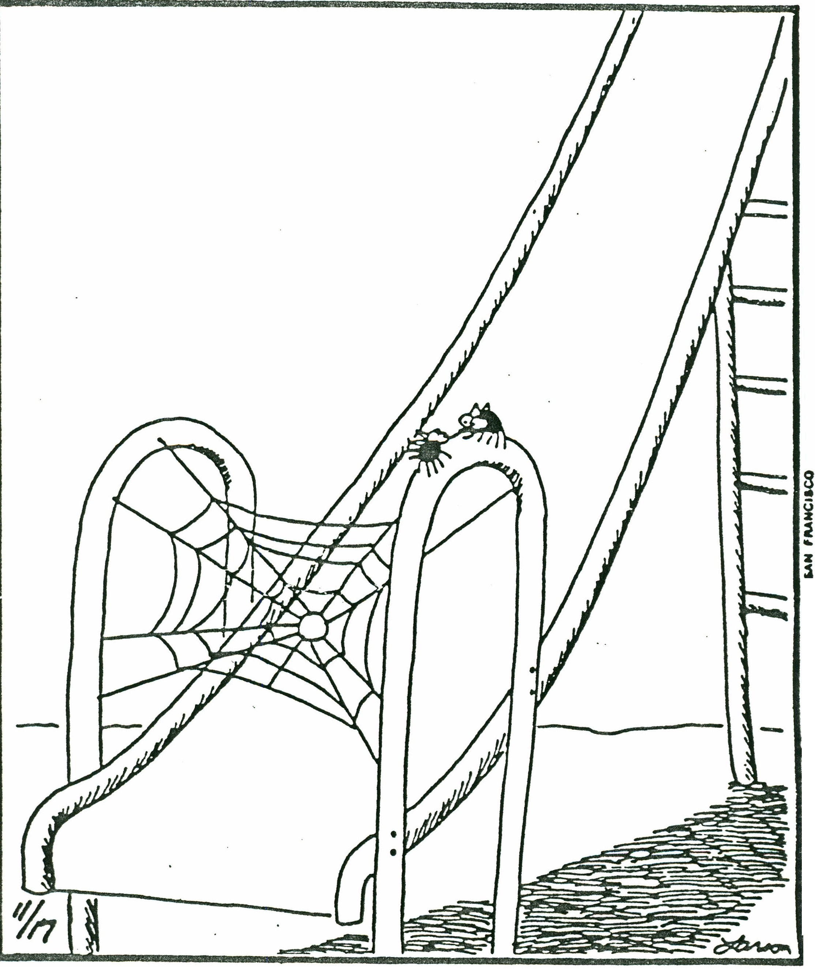

• ,.

SYSTEMS MODEL

CORE STEERING GROUP

* Base Survey Questionnaire

* Visitation Program

* Employment Surveys

* Hot Line Program

* Public Relations Events

[ USERS

Chamber

Riverport
Authority
Primary
Employers

Planning
Groups
Industrial
Foundations
News
Media

Engineering
Extension

River Park
Center
Local
Governments
Educational
Systems

BASE QUESTIONNAIRE SURVEY

110 Questionnaires Distributed
50+ Completion Target

1. Baseline measure of attitudes, characteristics, and perceptions of primary employers

2. Explore avenues whereby planning groups could work more effectively together

3. Determine potential roles that groups could play in being of greater assistance to primary employers

VISITATION PROGRAM

VISITATION-CONTACT QUESTIONNAIRE DEPLOYMENT OF CONTACT TEAMS
(2 member teams)
l

DEBRIEFING AND FOLLOW-UP
J
COMPANY FILES ESTABLISHED
l
LETTERS OF APPRECIATION AND EVALUATION

IMPLEMENTATIONAL TIMETABLE

MARCH

Core Steering Group Planning and Follow-up Complete

APRIL

Primary Manufacturers Survey Complete and Distributed to
Participants

Training of Contact Teams

Conduct Employment Trends Telephone Survey Survey Analysis Complete and Report Generated Visitation Program Begins

JUNE

Implementation of Red Flag/Hot Line Program

JUNE-JULY

Visitation Program Continues

SEPTEMBER OR OCTOBER

Major Industry Appreciation Event
(Keynote Speaker)

SEPTEMBER-NOVEMBER

Visitation Follow-Up Calls with Key Firms and/or Problem Areas

BUSINESS RETENTION/EXPANSION COMMITTEE VISITATION PROGRAM
PROGRAM OBJECTIVES

1) Recognize area primary manufacturers for their importance and contributions to the community.

2) Increase area industry awareness of incentives and
services available on a state and local level and provide expansion or problem solving assistance.

3) Identify opportunities for new industry/business attraction relating to goods and services utilized or produced by area manufacturers.

PROGRAM GOALS

1) Survey and visit the primary manufacturers annually.

2) Coordinate problem solving and follow-up based on needs identified through the visitation program.

PROGRAM OUTLINE

1) Develop visitation program schedule.

2) Select contact team members.

3) Develop contact list--

a) Key employers reserved for designated teams b) Determine priority target groups
4) Conduct training sessions for contact teams.

5) Distribution of surveys.

6) Review of surveys, identify action required, prioritize action items.

7) Coordinate action/response.

8) Follow-up, set up permanent files, later evaluation by client organization.

2-Visitation

STEPS FOR VISITATION PROGRAM

1) Finalize contact list and make preliminary team assignments.

2) Send cover letter explaining program and a survey form to company CEO. CEO will be asked to return survey prior to scheduling visitation.

3) After review of the survey, the contact teams will be responsible for establishing appointments.

4) The teams make the visits, refer to the survey and interview probes in making special note of problems or items requiring follow-up, make recommendations during the session as necessary, and return summary of session to Committee Chairman.

5) If necessary, dependent upon extent of action required, a debriefing session is conducted between team members and the Committee Chairman.

6) Letter of appreciation and evaluation form is sent to each company participant.

CONTACT QUESTIONNAIRE FORMAT

The contact questionnaire is desi ned to gather information pertaining specifically to the company s Owensboro/Daviess County location. It is further intended to foucs on problems the company may be experiencing here. All company data remains confidential. Some key areas the survey questionnaire addresses are:

1) Employment and labor force trends.

2) Future Plans--expansion, contraction, new technology, major corporate changes.

3) Problems--local and state problems, utility costs, barriers to production, etc. Emphasis will be placed on identifying problems that have a local or regional nature that can be realistically addressed.

4) Identification of raw materials and key resources needed for operation. Market areas and customer based outlined (this is an excellent source for new business attraction targets).

OWENSBORO-DAVIESS COUNTY CHAMBER OF COMMERCE

VISITATION QUESTIONNAIRE

1. Company Name: Address:
Telephone:

2. Name and title of company official responding:

3. Products manufactured or type of business:

4. Labor:

Numbers

A. Number of employees Production Office
Supervisory

B. Availability of labor adequate to fulfill your current and future needs? CHECK

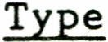

Production

Office

Supervisory
Yes No

What type of employees are the most difficult to find?

-1-

C. Productivity and quality of overall work force?

D. Union: Yes----- No-----

If Yes, union name-------------------------------

Any significant productivity lost due to strikes in the past two years?

Yes----- No-----

Percentage of workers belonging to union E. Turnover problems:

F. Unmet skills needs: G. Training needs:

5. Transportation facilities adequate for your operation?

6. Local utility facilities adequate for your operation?

7. Local banking facilities adequate for your operation?

-2-

8. Are there unmet industrial service needs in· the area, i.e., machine shops, plating, maintenance?

9. What is the company's expansion potential at your location?

10. Does your company have out-of-state suppliers who should be contacted for possible plant location in Owensboro?
If so, who?

11. Comment on the policies and attitudes of the following and how each organization can be of more service to you.

State Government:

Local Government:

Chamber of Commerce:

Local Economic Development Organizations:

Other:

-3-

12. Is there a raw material or another important local resource which caused you to locate here? Briefly describe.

13. Are there any raw materials or product components for your firm that you would rather buy locally versus your current source of supply? Would you like for us to provide you with information on possible area suppliers?

-4-

. . '

14. Why did your company locate in this community?

15. What is the single most important project or task which could be undertaken to make this community a better place to operate your company?

-5-

April 23,XXXX

&name&
&company&
&address&
&citystatezip&

Dear &first&,

We would like your assistance in a very important initiative being undertaken by the Owensboro-Daviess County Chamber of Commerce. A questionnaire is attached that we would like for you to fill out; it is being administered as part of The Chamber's Business Retention/Expansion Committee program initiatives for the year. The purpose of this ques­ tionnaire is to generate information from prominent leaders among the area's primary employers, and will be used as a basis for future planning and development efforts.

The specific objectives of this initial survey are threefold:
1) to provide a baseline measure of attitudes, characteris­
tics, and perceptions of the primary employers in the commu­
nity; 2) to explore possible avenues whereby the committee
and other Chamber groups could work more effectively toward common goals in meeting the needs of the firms; and 3) to
determine potential roles that The Chamber and other groups could play in being of greater assistance to the primary employers as part of these mutual assistance programs.

The information collected will be used on a confidential basis only to support the objectives of this special project. No information will be released that in any way could identify a particular respondent. The data will be computerized and analyzed, and a summary report containing the findings will be made available to all participants. After entry into the computer for tabulation purposes, the original questionnaire will be destroyed.

Please return your completed questionnaire in the enclosed envelope to The Chamber before May 3, 1990 so that reports can be ready within the month. Your assistance in this very important endeavor is appreciated.

Earl Fischer
Vice Chairman, Economic Development
Doug Frazier
President

Larry Minks
Chairman, Business Retention & Expansion Committee

CONFIDENTIAL

OWENSBORO-DAVIESS COUNTY CHAMBER OF COMMERCE MANUFACTURERS SURVEY QUESTIONNAIRE

The purpose of this questionnaire is to generate information from prominent leaders among the area's manufacturing community
to be used as a basis for future planning and development efforts.
It is being administered as part of The Chamber's Business
Retention/Expansion Committee program initiatives.

The information collected will be used on a confidential basis only to support the objectives of this special project of
the committee. No information will be released that could identify a particular participant. The data will be computerized and analyzed, and a research report containing the findings will be
made available to all study participants.

Your assistance and support in this very worthwhile endeavor is appreciated.

Earl Fischer, Vice Chairman, Economic Development

Doug Frazior, President

Larry Minks, Chairman, Business Retention & Expansion Committee

CONFIDENTIAL

1. Your age:

20-29 yrs _ 30-39 yrs _ 40-49 yrs _ 50-59 yrs 60 or more

2. Your Education (Check the blank indicating the highest educational level you have achieved.)

Grade
school
Some College

Some high school College graduate

High school graduate Post-graduate work

3. Have you completed any correspondence courses, technical courses, or seminars that have assisted you in your managerial and executive development?

None

Business related

Other (Please list)

4. How often do you attend meetings of the following kinds of organizations?' (Check appropriate blank)

Never Weekly Month1y Yearly

Service
(Rotary, Kiwanis, etc.)

Business
(Chamber of Commerce, etc.)

Cultural
(Musical, literary, etc.)

Religious
(Choir, church committees, etc.)

Political

Local government
(Planning board, etc.)

Regional government
(Planning, conservation, etc.)

Educational Institutions
(Brescia, Wesleyan, OCC)

Junior Achievement

-1-

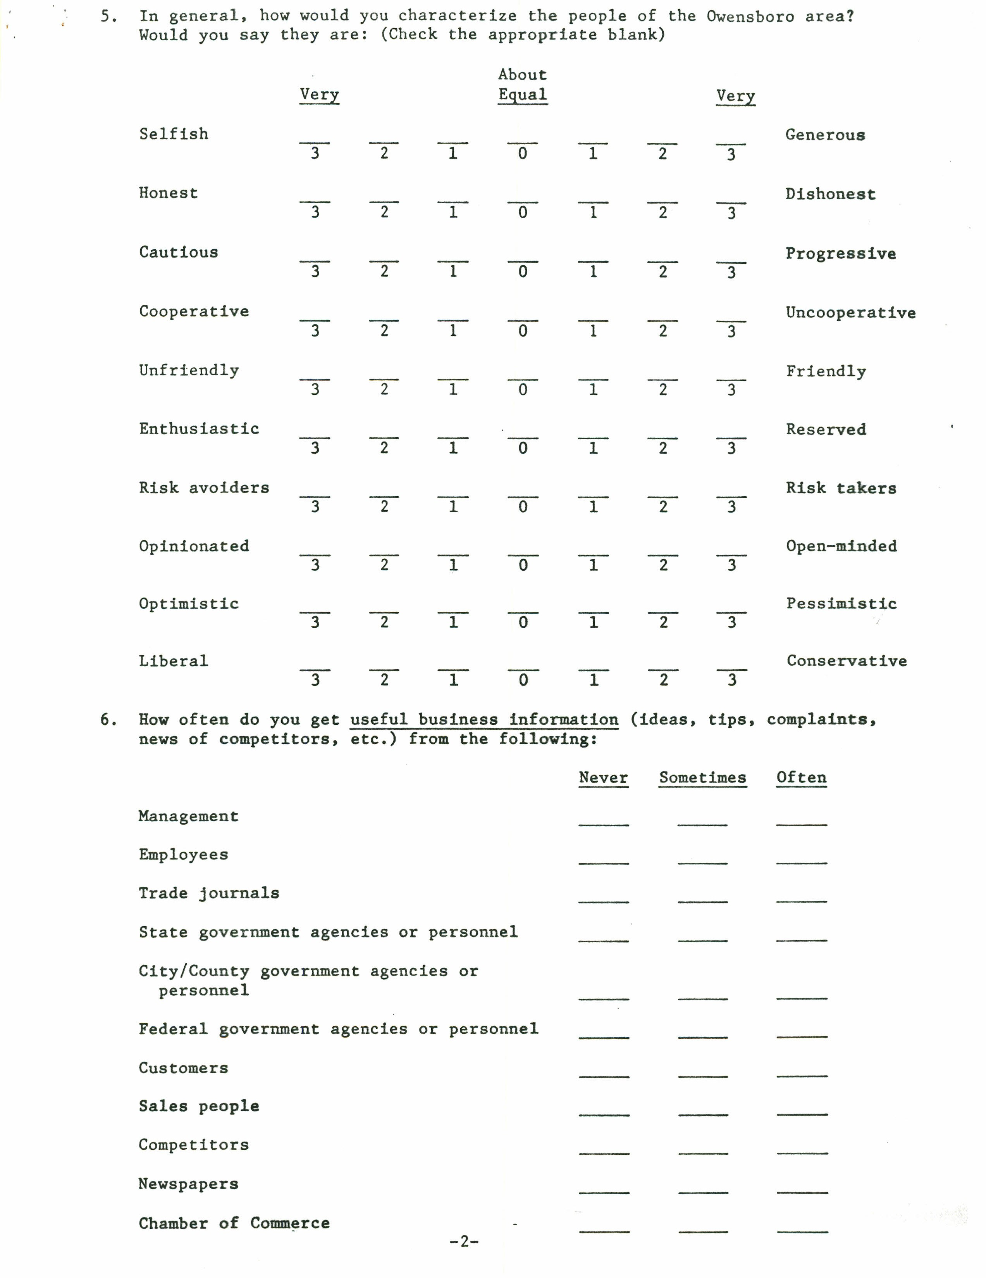

7. What newspapers, magazines, and other publications do you have time to read regularly?

Local newspaper (e.g. The Messenger-Inquirer) Kentucky newspapers
Out-of-state newspapers

News magazines (e.g. Time, Newsweek) Governmental bulletins, pamphlets, etc. Trade journals related to manufacturing
Business magazines (e.g. Business Week, Fortune)

8. How many hours do you normally spend each day:

up
None 0 to 1
up up
1 to 2 2 to 3
up up
3 to 4 4 to 5 more

Reading newspapers?

Reading books and magazines? Listening to the radio?
Watching television?

-3-

* In each of the next statements, mark an "X" in the blank that seems most appropriate

9. "In my business I have many opportunites to get ahead and improve my operations."

Strongly
Agree Indifferent
Strongly
Disagree

3 2 1 0 1 2 3

10. "The productivity and quality of my labor force is well above average."

Strongly
Agree Indifferent
Strongly
Disagree

3 2 1 0 1 2 3

11. "The absenteeism and turnover rate for my operation is well below the industry average."

Strongly |  |  | Strongly
Agree | Indifferent |  | Disagree
3 2 1 0 1 2 3

12. "The banks in the Owensboro area really help the local manufacturers."

Strongly |  |  | Strongly
Agree | Indifferent |  | Disagree··
3 2 1 0 1 2 3

13. Has your company established a new or expanded operation away from this location?

Yes No

14. What do you think are the chances of success for enlarging your business or introducing a major new product or service within the next five years? (Check the appropriate blank)

The chances are 1 in 10 that you would be successful.
The chances are 3 in 10 that you would be successful.

The chances are 5 in 10 that you would be successful.

The chances are 7 in 10 that you would be successful.
The chances are 9 in 10 that you would be successful.

The chances are 10 in 10 that you would be successful.

15. Rank the following as to what you would prefer most from your business. (Rank using numbers 1 through 10; 1 being most important.)

Wealth Influence

Respect Freedom

Security Achievement

Leadership Recognition

Challenge The Work Itself

16. In what areas could outside advice or assistance be most helpful in improving your operation? (Check all that apply)

Process Technology Quality Control

Forecasting and Aggregate Planning
New Product Planning

Inventory Control
Work Improvement

Purchasing and Materials
Management |  | Facilities Layout
 |  | EPA
 |  | Other

Project Planning

----- Maintenance

17. From which organizations do you think advice or assistance for businesses should come?

State government agencies |  | Schools of Business
---- Regional planning organizations |  | Federal agencies
Local service organizations |  | Outside professional

(i.e., Skills, Inc.)
consultants

Chamber of Commerce No one

18. Are you currently receiving outside advice or assistance?

Yes
---- No

If yes, from where?

19. Does your current position provide you with a sense of job satisfaction?

Yes No

20. If no, why not? (Rank as many as apply using "1" for most important, "2" for next most important, etc.)

Limited opportunities in my operation

Not sufficiently profitable or successful

Dislike type of business

No control over actions

Low-prestige business

Business too risky

Limited opportunity in Owensboro area

Other (List)

*Note: Most firms have several turning points in their development.
Think of such critical turning points in this business since you have been here. (Such things as new products, new
I
equipment, expansion, new branches, change in layout, change
in organization, new marketing arrangements, branching out
into new business, new sources of money, new competition, etc.)

21. What factors do you consider most important in stimulating major changes in your business? (Check all that apply)

Competition Personal management situation

--- National economic conditions
Financial considerations

--- Local economic conditions
New opportunities

Corporate environment Business conditions
in Owensboro-Daviess County

Technology

--- Management
--- Labor
EPA

Other (List)

-6-

22. What do you consider the major handicaps in making major changes in your business (Check all that apply)

Lack of financing Complexity of projects

Negative city or county attitude Zoning

Lack of profit potential Adequate managerial skills not available

Insufficient time

Site Limitations
--- Labor
--- EPA

Other:

23. Over the past 5 years, unit volume in your business has, on the average:

Declined 10 percent or more· per·year

Declined, but less than 10 percent per year

Remained about the same

Increased, but less than 10 percent per year

Increased between 10 and 25 percent per year

Increased more than 25 percent per year

24. Over the past five years, your sales have exceeded your expenses in:

All five years Two of the ive years

Four of the five years One of the five years

Three of the five years In none of the years

25. Over the past five years, your sales have:

Increased each year

Increased in four of the five years

Increased in three of the five years

Increased in two of the five years

Increased in one of the five years

Did not increase in any year during this period

-7-

26. Please rate the following factors as they relate to your site and/or its operation.

5 4 3 2 1 0

very
good
good
average poor very poor
no answer

a) Proximity to customers

b) Proximity to suppliers and materials
c) Proximity to transportation network for product distribution

d) Availability of labor

e) Availability of support services (i.e., financial, legal, equipment, technical, research & development, other) If other, list in (v)space below

f) Water service costs g) Sewer service costs h) Electric costs
i) Gas costs

j) Local tax rates
k) Opportunities for local government inducements
(i.e., tax abatements, etc.)
1) Education
m) Training program
n) Costs of property and construction
o) Accessibility of affordable housing and amenities

p) Telecommunications
q) Solid waste disposal
r) Hazardous waste disposal s) Police protection
t) Fire protection
u) Street conditions
v) Other -------------------------------------- ----------------

-8-

27. How do you as a business person rate the importance of the following on local business and economic development in the future? (Check one blank in each row)

Definitely
Negative No
Value Slightly Value
Definitely
Positive
Slightly Value

Owensboro Airport

New Mid-America Air Park Spec Building Program
Owensboro as County Seat

Establishment of Owensboro­
Daviess County Industry, Inc.

UK-GRADO Industrial
Extension Office
Owensboro Riverport Authority Agricultural base of the
county

Appearance of the city

River Park Center

Proposed access to I-64

Merged government

The cultural environment

28. What is the lowest probability of success that you would consider acceptable before you would expand or change your business in a major way?

--- One in 10 chance that you would be successful
Three in 10 chance that you would be successful

Five in 10 chance that you would be successful

Seven in 10 chance that you would be successful

Nine in 10 chance that you would be successful

Ten in 10 chance that you would be successful

29. Over the past two years, have you enlarged your business or established new product lines or services?

--- Yes
--- No

-9-

30. To finance corporate expansion or provement, which of the following do you use, or which may you be interested in using in the future? (Check those that apply)

USE ANTICIPATE

a) Parent company b) Cash flow
c) Local conventional financing (i.e., banks)

d) Out-of-state conventional financing

e) Local government financing tools (i.e., Industrial Revenue Bonds)

f) Federal or state financing programs (i.e., CDBG/UDAG)

g) Small Business Administration programs

h) Venture capital i) Stock offering
j) Research and development partnership

k) Other -----------------------
i

31. Targeting of new industries for the area or new markets for area industries is often facilitated by knowing what products are produced at each of your area manufacturers and processors and the pr
raw materials needed for manufacturing or processing.

a) Would you list the finished product(s)of your firm:

(if additional space is needed, please write on the back of the page)

b) Would you list the primary raw materials utilized by your f±rm
and source(s):

RAW MATERIALS SOURCE

-10-

32. Each firm generates what is commonly referred to as scrap, waste, or superfluous material created in manufacturing or processing. In some instances, material classed as such, by one firm, may be usable as a primary or secondary raw material by other firms (Examples: Steam, water, spent acid, excess metal and other types of offal, etc.)
Would you list all such materials that you might place in this category.

(a) Do you currently have the capacity or potential for recycling waste products?

Yes
--- No

33. About what percentage of your dollar purchases for your operation's supplies and equipment are made within the Owensboro area? (Check the appropriate column)

Supplies Equipment

0 to 19 percent

20 to 39 percent

40 to 59 percent

60 to 79 percent

80 to 100 percent

34. About what percentage of your personal and family purchases are made in Owensboro?

0 to 19 percent 80 to 89 percent

20 to 39 percent 90 to 94 percent

40 to 59 percent 95 to 100 percent

60 to 79 percent

-11-

35. How do you as a business person evaluate the impact of the following on local business and economic development:

Definitely Negative Influence
Slightly Negative No Influence Influence
Slightly Definitely Positive Positive Influence Influence

The Messenger-Inquirer

Local banks

Service clubs (e.g. Lions) Churches
Chamber of Commerce

City Planning Commission

City Manager

County Fiscal Court

City Government

Police Department
(crime rate)

Owensboro Community College

Local Colleges (Brescia and Kentucky Wesleyan)

Local school systems

Owensboro-Daviess
County Industry, Inc.

Green River Area
Development District

Owensboro Riverport
Authority

Owensboro-Daviess County
Industrial Foundation

Owensboro-Daviess County
Labor-Management Committee

Cooperation between labor
. and management

West Kentucky Small Business Development Center

Cooperation between business people

-12-

* In the next statements, mark an "X" in the blank that seems most appropriate.

36. "In the past, the relationship between Owensboro business people and local governmental officials has been beneficial to the area."

Strongly
Agree Indifferent
Strongly
Disagree

3 2 1 0 1 2 3

37. "The majority of people in Owensboro don't care about taking an active part in improving this community."

Strongly
Agree Indifferent
Strongly
Disagree

3 2 1 0 1 2 3

38. "Good local government is a function of how much you spend on it."

Strongly
Agree Indifferent
Strongly
Disagree

3 2 1 0 1 2 3

39. To what extent do you support the expansion of Owensboro as a tourist center?

Strongly
Favor
Somewhat
Favor Indifferent
Somewhat
Oppose
Strongly
Oppose

2 1 0 l 2

40. To what extent do you support the merger of city and county governments?

Strongly
Favor
Somewhat
Favor Indifferent
Somewhat
Oppose
Strongly
Oppose

2 l 0 1 2

-13-

41. To what extent do you support the establishment of outside industry in the Owensboro area over the next few years?

Strongly
Opposed
Somewhat
Opposed Indifferent
Somewhat
Favor
Strongly
Favor

2 1 0 1 2

42. Do you feel the public services provided in Owensboro and Daviess County are:

Worth more than the taxes you pay?

Worth about what you pay for them?

Worth less than the taxes you pay?

43. Do you think the current planning in Owensboro-Daviess County is adequate to solve the area's long-range problems?

----- Yes No

COMMENTS:

44. Consider your overall attitude toward the Owensboro area. Which one of the following statements is closest to your personal view. "Owensboro-Daviess County is:

"Changing too quickly for my taste."

"Just fine the way it is."

"Not keeping up with the times."

45. -In your opinion, is Owensboro and Daviess·County becoming a better or worse place to have a business?

Much
Better Same
Much
Worse

3 2 1 0 1 2 3

46. Why?

1.
2.
3.

47. In your opinion, is Owensboro and Daviess County becoming a better or worse place to live?

Much
Better Same
Much
Worse

3 2 1 0 1 2 3

48. Why?

1.
2.
3.

Your Name

Title ------------------------------------------ ------- Firm

Your Responses Are TOTALLY CONFIDENTIAL Thank You For Your Cooperation

-15-

