SoutheasternOklahoma State University
Durant, Oklahoma, 405 -924 -0121

Center for Organizational Effectiveness
School of Business and Industry

MANAGEMENT DEVELOPMENT: A PRACTICAL APPLICATION INTEGRATING SYSTEfviS THEORY AND ORGANIZATION DEVELOPMENT

by

Lawrence C. Minks

Southeastern Oklahoma State University and
C. Srinivasan

Storage Technology Corporation

* * * * * * * * * * * * * * * * * * * * * * * * * * *
* *
* Prepared for The Twenty-Fifth Annual Meeting *
* Southwest Division of The Academy of Management *
* March 9-12, 1983 · *
* Houston, Texas *
* *
* * * * * * * * * * * * * * * * * * * * * * * * * * *

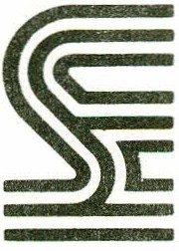

MANAGEMENT DEVELOPMENT: A PRACTICAL APPLICATION INTEGRATING SYSTEMS THEORY AND ORGANIZATION DEVELOPMENT

ABSTRACT

As the emphasis in management continues to shift toward partic­ ipation, collaboration, and confidence, rather than traditional authoritarian-bureaucratic processes, systems theory and organization development principles are being utilized extensively by enlightened organizations. The role of management is to create the proper environ­ ment that allows for creativity and change to flourish. The long-run survival of an organization today can be importantly influenced by effective management of an OD process that stimulates creativity and fosters innovative processes and systems in response to both external and internal demands. An example of such a process is outlined in
this paper: a process that effectively integrates organization develop­

ment and systems theory into a creative and synergistic approach to management development.

Introduction

Systems theory represents a body of knowledge describi ng how organi ­

zations are formed and their resulting behavior, the boundaries both within and outside the organization, the interaction of individual components, and the interaction between the organization and its environment. Organizations represent systems, and the degree of interdependency and interaction of different components and reaction to the environment are key aspects of organizational development and change (French and Bell, 1978).
There have been various schools of thought relative to how organi­ zations develop and the resulting change processes involved. The classical view emphasizes a clear definition of organizational responsibility and
the enforcement of authoritarian principles as the primary directing

force. More contemporary views tend to emphasize decentralization of responsibility, acceptance of authority, and highly participative methods. These contemporary orientations are far different from the traditional patterns of 11 Scientific management" and 11 bureaucratic tendencies. The central emphasisin the participative approaches are:
-Much wider participation in decision-making and problem­

solving, rather than centralization of these functions.

-Group formation and team building, rather than individual processes, as the basic unit of operation for the organi­ zation.
-The manager as the agent for maintaining and stimulating

skilldevelopment, communication, and coordination, rather than as the agent of the downward flow of authority to the individual.

-Mutua1 co11aboration, confidence, and prob1em--solving, rather than authority, as the basic integrating force in the organization.
-The professional career growth of members of the organiza-

tion to greater levels of responsibility and achievement, rather than authoritarian control of the individual's per- formance.

The Management Development Program (MOP): An Open Systems Approach

Most approaches aimed at effectively integrating organization development and systems theory may be viewed as synergistic. This inte- gration is of practical significance to senior executives because of their concern with effectiveness of the total enterprise. They are res- ponsible for negotiating an array of interactions with external groups, and for designing internal systems that utilize available resources to
best advantage (Newman and Logan, 1976). Consequently, senior executives

are likely to be interested in a synergistic design aimed at solving an organization's current problems as well as facilitating long-term prob­ lem solving and self-renewing competence (French, Bell, and Zawacki,
1978).

One such synergistic approach is the Management Development Program (MOP), designed and developed by the corporate training and development department of a major manufacturer of computer peripheral products.
This optional three-phased program targets each division of the company, and it involves all managers in the division in a series of workshops
and developmental activities aimed at improving their teamwork, productivity,

and organizational effectiveness. The three phases of the program are: (1) Team Building; (2) Managing Human Performance; and (3) Career Development.
The program is based on systems theory, since it considers each participating division as an open sys.tem, cons.istent with the basic input-output conversion model. According to this approach, external sources involving support from top management, the employee relations
department, and the training staff elicit inputs from participating man­

agers. These inputs are processed through program activities and work- shops, and are translated into the outputs of improved teamwork, pro- ductivity, and organizational effectiveness. The outputs in turn are fed to user base including individual contributors and other divisions. Figure 1 is a graphic representation of the MOP model.

Insert Figure 1 about here

Thus, from a systems level perspective, a multiple-criterion for assessing organization dynamics emerges involving component units, dimen­ sions, boundaries, networks, feedback mechanisms, integration, and adap- tation. The systems concept leads managers to a much different way of thinking about problems (Schein, 1980):
-From a total systems standpoint, how does the organization adapt to its environment?

-How does the organization obtain and process information?

-What are the mechanisms that exist for translating informa- tion into strategic operational changes?

-How flexible are internal operations in coping with change?

-Can the organization's ability to cope be improved?

For a system to function at desired levels of performance, it

must continually adapt to both internal and external demands and needs. This process is called homeostasis, which means the dynamics involved
in maintaining or re-establishing equilibrium, and can be used by managers in understanding various ways of increasing organizational effective-
ness. The process of change in some aspect of the organization's envi ­ ronment (internal or external) results in change activities that end with the organization adapting to meet the need or demand imposed by the change. This process is referred to by Schein (1980) as the organization's adap­ tive coping cycle.
As organizations have come to be perceived as dynamic, coping, adap­ tive systems, the concepts of how they change and how change efforts can be influenced and managed have become more refined. One of the most rapidly expanding areas during the past several decades has become known as "organization development."

Integrating Organization Development

What is organization development (OD)? Huse (1980) defines organi­ zation development as (1) deliberate, reasoned, introduction, establish­ ment, reinforcement, and (2) spread of change for (3) the purpose of improving an organization's effectiveness and health. To be used pro­ perly, 00 must be viewed as a long-term process (rather than a specific technique) to improve organizational problem-solving and renewal pro­ cesses with particular attention to creating a more effective and collab­ orative management of organizational culture (French and Bell, 1978).

In response to change, it is a long-term strategy for strengthening human resource processes in organizations which improve the func­ tioning of the system, enabling the system to more effectively achieve its objectives (Lippitt, 1969).
Organization development deals initially with diagnosis of prob­ lems in the system in order to improve it. This is accomplished through interventions with the system. Chris Argyris (1973) defines
11 intervention11 as entering into an ongoing system of relationships, to come between or among persons, groups, or objects for the primary purpose of helping them. The intervention model which is employed in most OD efforts is action research (French and Bell, 1978). The MOP
is also an organization development intervention, and it can be classi­

fied as action research. The program is a normative process that pro­ ceeds through a series of ongoing relationships with a primary helping mode of operation. The processes involved include the basic stages of the action research model: 1) preliminary diagnosis, 2) data gathering,
3) data feedback, 4) discussion and exploration, 5) action planning, and

6) implementation.

Intervention Components

The preliminary program activity consists of a briefing.for the division vice president and all managers reporting directly to him/her. In this briefing, the management development program is described and
explained, and all elements of it are open for discussion by the attending

managers. After clarification of the program's purpose and process, the vice president contracts informally with the training department for all managers in the division to participate in the program. The contractual

stage is followed by the collection of information from participating managers by the training department, using questionnaires and personal interviews within the division to diagnose issues and identify problems of primary concern.
With the aid of the data gathered, facilitators from the training department design a client-specific Team Building workshop, which con­ stitutes the first phase of the MOP. Workshops are then held for the division-level management team, and for all department-level management teams. The emphasis of team building is upon organization problem solving and action planning on issues identified by managers during the data-gathering stage. In these two-day off-site workshops, the range
of activities varies for each division, since different divisions

experience different problems. Discussions by participants during these workshops result in the development of action plans aimed at practical
on-the-job application. A synopsis of the first phase is provided in

Figure 2.

Insert Figure 2 about here

The second phase of the MOP, called Managing Human Performance (MHP), is a three-day workshop. The MHP is a skill development intervention, built on the behavior modeling theory of adult education, and based on an earlier diagnosis of the organization. In this workshop, managers learn
to (a) set performance standards and performance expectations with their subordinates; (b) observe, evaluate, and document job-related performance

7 behavior; (c) coach for improved job performance during a review period; (d) prepare and conduct performance appraisal interviews with subordi­ nates; and (e) formulate professional development career plans. This
phase is highlighted in Figure 3.

Insert Figure 3 about here

A Career Development workshop constitutes the third phase of the program. The purposes of Phase III are to increase participating managers1 skills in employee development and to contribute to the corporate manage ment succession and development program. This workshop also involves all managers in the division and consists of at least two sessions, one for
the division-level management team, and another for department-level

management teams. Participants develop personal career development plans

that later lead to developmental discussions with their supervising managers. In addition, each manager learns to assist subordinates in preparing their career development plans. Figure 4 contains a summary of Phase III.

Insert Figure 4 about here

The grouping of participant managers (as shown in Figure 5)in the various phases of the MOP is based on the 11 linking pin11 concept (Likert, 1961). The approach allows for top-down division training
in goals and objectives setting processes within a team environment.

8

This results in a training plan for each manager with action plans developed for improved teamwork and organizational effectiveness..

Insert Figure 5 about here

The participant grouping is based on theories that deal with the management of the human organization. It is more concerned with influence and expectation than formal structure, with communication rather than downward information flow, and with satisfaction rather than alienation. The grouping regards leadership and the management systems that emerge across managers and groups as the primary causal factors in organizational functioning. The arrows in Figure 5 are shown as being two-way because
at every level managers are members of two groups simultaneously; they

are subordinates in the group above and superiors in the group below. This dual membership serves the purpose of linking the organization mem bers together and is why management teams are grouped on a division-level and department-level basis. Thus, a two-tier team level is provided for the MOP intervention, as depicted in Figure 6, that targets both levels for all phases of the program.

Insert Figure 6 about here

9

The Role of Management in Chrange Efforts

It is management's responsibility to develop an organizational environment that allows creativity and change to flourish. Developing this type of cli mate is not an easy task because most organizations
are not basically creative. They spend a great deal of time and energy

on routine, operational aspects rather than concentrating on the realiza­

tion of creative potential.

The dominance of this operational mentality requires that management develop specific systems and processes (that ultimately will result in philosophy and culture) that encourages creativity and fosters innovation and change. The long run survival of an organization today can be impor­ tantly influenced by effective management of an OD process that facilitates constructive change in response to both external and internal needs and demands placed on the system. Effective use of OD processes can enable
a company to adapt and orient itself to emerging requirements. Innovative

and successful companies manage the future, others are managed by the present, and still others are overwhelmed by the future.
It is necessary for management to elaborate processes. for organiza

tional change and improvement in the same intensive manner as strategic plans and functional plans are developed on an annual basis. Managers need to conceptualize models that reflect a systems perspective of their organizations, like the MOP program (as overviewed in Figure 7), if they are to be successful in managing 00 activities.

---40e"----------- -· ---------------------....,.,..__..,...

Insert Figure 7 about here
-----""'f----..--- --_.-------------------·

10

It is believed that this perspective has wide application across diverse types of organizational settings. It can be beneficial to manage... ment in a number of ways: a) facilitates better understanding of rela tionships that exist among various subsystems and key organization dimen sions that guide effective diagnosis and problem solving, b) facilitates
a better understanding of various interventions relative to subunits or

dimensions allowing more critical analyses of the effective use of change methodology, and c) facilitates managerial contribution to the setting
of objectives for desired outcomes of OD programs and how change pro­

cesses will influence these outcomes.

The most important thing to remember is that successful organization development and change efforts are dependent upon people. Although there are numerous process structures and aids in diagnosis and implementation, it is the people who make it work. If management wants to implement a process like the MOP they must realize that i.t takes time to build an integrated and functioning system, that it is costly in terms of manage ment commitment and human resource development, and that it requires
long-term managerial discipline. Nothing worthwhile is easy.

Figure 1.

The Management Development Program: An Open Systems Approach

PARTICIPATING DIVISION

EXTERNAL SOURCES . INPUTS - -
-+PROCESS
.,.,. OUTPUTS

-
' .-.usER BASES

.top management Data from participating
.Team Bui. lding
.Managing Human
.mutual functi.oni ng

.individual contributors

.employee relations

.training and development
managers
"

Performance
.Career Devel­
opment
.effectiveness
.producti. vity
+
'
.other divisions

Figure 2.

Phase I: Team Building Workshop

Description Outcomes

.Designed to respond to participants• assessment of their own organizational functions

.Includes all managers in a division in functional groups

.Focus on objectives, procedures, responsibilities, interdependencies, and communications
.Clarification of the purpose and priorities of work group

.Increased team effectiveness

.Development of action plans to be implemented on the job

.Definition of individual training needs

Figure 3.

Phase II: Managing Human Performance

Description Outcomes

Designed to prepare participants for on-the-job implementation of perform­ ance review skills to support division­ wide systematic application of
effective performance reviews by

. increasing the effectiveness of managers in managing employee performance
increasing employee,participation establishing reliable and con­
structive performance evaluations

. Improved communication and motivation skills

Establishment of procedures for observing, evaluating, and docu­ menting job performance

. Development, with subordinates, of performancstandards on job targets using an MBO format

. Strategies for planning job and development activities

. Demonstration of constructive performance-based feedback and coaching

Figure 4.

Phase III: Career Development Workshop

Description Outcomes

Activities and tools to help each participant identify skills, job priorities, job success factors, and skill discrepancies in order to prepare an individualized career plan

. Exercises to improve skills in helping subordinates develop career plans

. Overall goal to improve relation­ ships between managers and their subordinates
. Preparation of a personal career action plan by each manager

. Increased skill in career counseling by managers

Participant Manager Grouping

Division
Manager

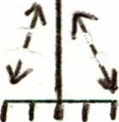

Department
Managers
Division
Vice-President

1
Division
Manager

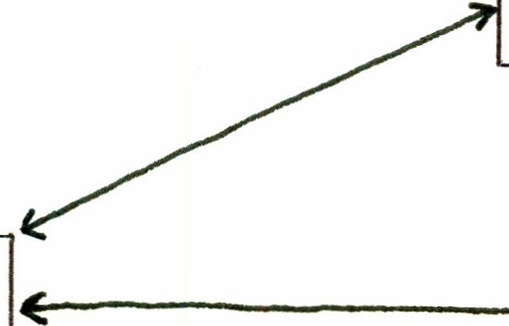
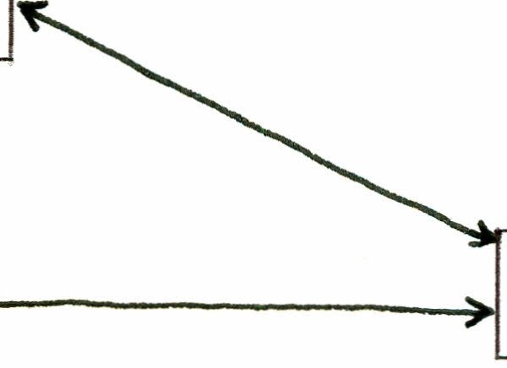
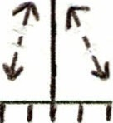

Department
Managers

Division
Manager

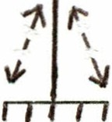

Department
Managers

---Division-level management team

Department-level management team

Application of MOP to Participant Target Group

Management De:rlopment Program

Program briefing for division VP
and direit reports
Agreement :r participate

Data Gathering & Diagnostics

Tier 1 Tier 2
Division Level Department Level
Management Management
Team Teams

Phase | I | Team Building | - | Team Building
Phase | II | Managit Human | -- -- -- | Managing Human
Pertorance Performance
Phase | III | Career | ---+ | Career
 |  | Development |  | Development

References

Argyris, Chris (1973) Intervention Theory and Method: A Behavioral
Science View. Reading, Mass.: Addison-Wesley, p. 15.

Beer, Michael (1980) A social systems model for organization development.
In Thomas G. Cummings (ed.)Systems Theory for Organization
Development. New York: Wiley.

French, Wendell L. and Cecil H. Bell , Jr. (1978) Organization Development: Behavioral Science Interventions for Organization Improvement. Engle­ wood Cliffs, N.J.: Prentice-Hall , pp. 14-38.

French, Wendell L., Cecil H. Bell , Jr., and Robert A. Zawacki (eds.)(1978) Organization Development: Theory, Practice, and Research. Dallas: Business Publications, Inc., p. 67.

Harrison, Roger (1970) Choosing the depth of organizational intervention.
Journal of Applied Behavioral Science6 (2).

Huse, Edgar F. (1980) Organization Development and Ctlange. St.. Paul , Minn.: West, p. 23.

Katz, Daniel and Robert L. Kahn (1967) The Social Psychology of Organi­
zations. New York: Wiley.

Leavitt, H. (1965) Applied organizational change in industry. In J. March
(ed.) Handbook of Organizations. Chicago: Rand McNally.

Likert, Rensis (1961) New Patterns of Management. New York: McGraw-Hill ,
p . 133.

Li ppitt, Gordon L. (1969) Organization Renewal. New York: Appleton­ Century-Crofts, p. 1.

Newman, William H. and James P. Logan (1976) Strategy, Policy and Central
Management. Cincinnati: South-Western, p. 6.

Ouchi , William (1981) Theory Z: How American Business Can Meet the
Japanese Challenge. Reading, Mass.: Addison-Wesley.

Pascale, Richard T. and Anthony G. Athas (1981) The Art of Japanese Management: Applications for American Executives. New York: Simon & Schuster.

Schein, Edgar H. (1980) Organizational Psychology. Englewood Cliffs, N.J.: Prentice-Hall , p. 233.

